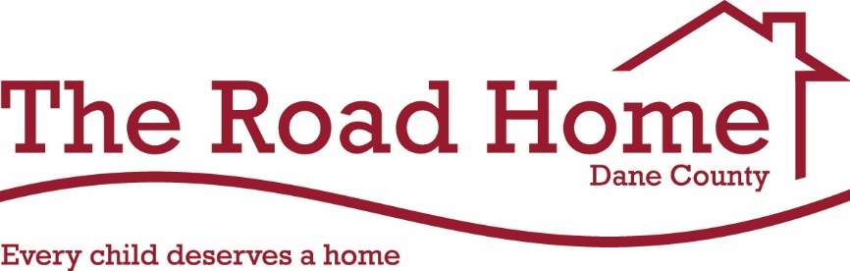
2019 Monthly Teams

Each month, we will highlight our amazing congregations/teams that continue to support the mission of The Road Home Dane County. For the month that your team is assigned, your group will be asked first to help with recruiting volunteers when needed, promote donation drives for our most needed wish list items, to share the mission of The Road Home Dane County, etc.
Thank you for your support and commitment to the mission of The Road Home Dane County.

January 2019
TEAM VIOLET: Temple Beth El, Blessed Sacrament, Bethany United Methodist and Shraarei Shamayim

TEAM PINK: Midvale Community Lutheran, Prairie Unitarian, Glenwood Moravian, St. James’ Lutheran (Verona) and Beth Israel Center

February 2019
TEAM BLUE: Covenant Presbyterian Church, First Baptist, Blackhawk and Mt. Olive Lutheran

TEAM YELLOW: Immanuel Lutheran Church, Plymouth UCC, Messiah Lutheran, City Church and City Sanctuary of God in Christ

March 2019
TEAM GREEN: Lake Edge UCC, Lake Edge Lutheran, St. Stephen’s Lutheran, Monona United Methodist, City Church and Heartland Church (Sun Prairie).

TEAM RED: Lakeview Lutheran Church

April 2019
TEAM GOLD: Holy Mother of Consolation, First Presbyterian (Oregon) and Peoples United Methodist

TEAM MAGENTA: Trinity Lutheran, Bethel Lutheran and The Church of Jesus Chris of Latter Day Saints

May 2019
TEAM PURPLE: Luther Memorial, Geneva Campus and Christian Science Neighbors

TEAM SILVER: Middleton Community UCC, Good Shepherd Lutheran and The Church of Jesus Christ of Latter Day Saints

June 2019
TEAM ORANGE: Christ Presbyterian Church, First Unitarian Society and Fountain of Life

TEAM INDIGO: Dale Heights, St. Dunstan’s Episcopal, Lutheran Church of the Living Christ and Iglesia Restauracion Y Vida

July 2019
TEAM VIOLET: Temple Beth El, Blessed Sacrament, Bethany United Methodist and Shraarei Shamayim

TEAM PINK: Midvale Community Lutheran, Prairie Unitarian, Glenwood Moravian, St. James’ Lutheran (Verona) and Beth Israel Center

August 2019
TEAM BLUE: Covenant Presbyterian Church, First Baptist, Blackhawk and Mt. Olive Lutheran

TEAM YELLOW: Immanuel Lutheran Church, Plymouth UCC, Messiah Lutheran, City Church and City Sanctuary of God in Christ

September 2019
TEAM GREEN: Lake Edge UCC, Lake Edge Lutheran, St. Stephen’s Lutheran, Monona United Methodist, City Church and Heartland Church (Sun Prairie).

TEAM RED: Lakeview Lutheran Church

October 2019
TEAM ORANGE: Christ Presbyterian Church, First Unitarian Society and Fountain of Life

TEAM INDIGO: Dale Heights, St. Dunstan’s Episcopal, Lutheran Church of the Living Christ and Iglesia Restauracion Y Vida

November 2019
TEAM PURPLE: Luther Memorial, Geneva Campus and Christian Science Neighbors

TEAM SILVER: Middleton Community UCC, Good Shepherd Lutheran and The Church of Jesus Christ of Latter Day Saints

December 2019
TEAM GOLD: Holy Mother of Consolation, First Presbyterian (Oregon) and Peoples United Methodist

TEAM MAGENTA: Trinity Lutheran, Bethel Lutheran and The Church of Jesus Chris of Latter Day Saints

