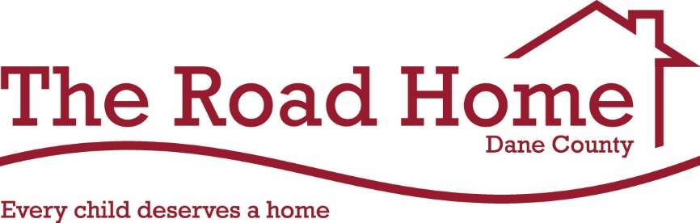
2020 Monthly Teams

Each month, we will highlight our amazing congregations/teams that continue to support the mission of The Road Home Dane County. For the month that your team is assigned, your group will be asked first to help with recruiting volunteers when needed, promote donation drives for our most needed wish list items, to share the mission of The Road Home Dane County, etc.
Thank you for your support and commitment to the mission of The Road Home Dane County.

January 2020
TEAM VIOLET: Temple Beth El, Blessed Sacrament, Bethany United Methodist and Shraarei Shamayim

TEAM PINK: Midvale Community Lutheran, Prairie Unitarian, Glenwood Moravian, St. James’ Lutheran (Verona) and Beth Israel Center

February 2020
TEAM BLUE: Covenant Presbyterian Church, First Baptist, Blackhawk and Mt. Olive Lutheran

TEAM YELLOW: Immanuel Lutheran Church, Messiah Lutheran and City Sanctuary of God in Christ

March 2020
TEAM GREEN: Lake Edge UCC, Lake Edge Lutheran, St. Stephen’s Lutheran, Monona United Methodist and Heartland Church (Sun Prairie).

TEAM RED: Lakeview Lutheran Church

April 2020
TEAM GOLD: Holy Mother of Consolation, Madison Church of Christ and New Volunteers Team

TEAM MAGENTA: Trinity Lutheran, Bethel Lutheran, The Church of Jesus Chris of Latter Day Saints and The Bridge

May 2020
TEAM PURPLE: Luther Memorial, Geneva Campus and Christian Science Neighbors

TEAM SILVER: Middleton Community UCC, Good Shepherd Lutheran and The Church of Jesus Christ of Latter Day Saints

June 2020
TEAM ORANGE: Christ Presbyterian Church and First Unitarian Society

TEAM INDIGO: Dale Heights, St. Dunstan’s Episcopal, Lutheran Church of the Living Christ and Iglesia Restauracion Y Vida

July 2020
TEAM VIOLET: Temple Beth El, Blessed Sacrament, Bethany United Methodist and Shraarei Shamayim

TEAM PINK: Midvale Community Lutheran, Prairie Unitarian, Glenwood Moravian, St. James’ Lutheran (Verona) and Beth Israel Center

August 2020
TEAM BLUE: Covenant Presbyterian Church, First Baptist, Blackhawk and Mt. Olive Lutheran

TEAM YELLOW: Immanuel Lutheran Church, Messiah Lutheran and City Sanctuary of God in Christ

September 2020
TEAM GREEN: Lake Edge UCC, Lake Edge Lutheran, St. Stephen’s Lutheran, Monona United Methodist and Heartland Church (Sun Prairie).

TEAM RED: Lakeview Lutheran Church

October 2020
TEAM ORANGE: Christ Presbyterian Church and First Unitarian Society

TEAM INDIGO: Dale Heights, St. Dunstan’s Episcopal, Lutheran Church of the Living Christ and Iglesia Restauracion Y Vida

November 2020
TEAM PURPLE: Luther Memorial, Geneva Campus and Christian Science Neighbors

TEAM SILVER: Middleton Community UCC, Good Shepherd Lutheran and The Church of Jesus Christ of Latter Day Saints

December 2020
TEAM GOLD: Holy Mother of Consolation, Madison Church of Christ and New Volunteers Team

TEAM MAGENTA: Trinity Lutheran, Bethel Lutheran, The Church of Jesus Chris of Latter Day Saints and The Bridge

Each assigned month, your congregation will receive any upcoming volunteer opportunities and/or any needs for our family events first. We ask that your congregation also conduct a wish list supply drive of our most needed wish list items at the current time. That information will be provided to each monthly team.
Thank you for your continued support of the mission of The Road Home Dane County!

